OPERATING SYSTEMS
PROJECT DOCUMENTATION
READERS–WRITERS
CONCURRENT DATABASE SIMULATOR
OS Hackathon • Team No. 23

Student ID | Team Member
2520030303 | PODILA BHARGAVA RAMA SASTRY
2520030164 | MARGANI DIJENDRA VENKAT KUMAR
2520030069 | GIRINENI HEMASWI

Document Control
Item | Details
Project title | Readers–Writers Concurrent Database Simulator
Project category | Operating Systems / OS Hackathon
Team number | 23
Implementation language | C
Target platform | Linux / Ubuntu
Build system | Makefile and GCC
Concurrency APIs | POSIX threads, pthread_rwlock_t, pthread_mutex_t
Validation status | 7 tests passed, 0 failed, overall result PASS

Purpose of this document: to explain the project's problem, design, implementation modules, execution steps, validation approach, results, limitations, and possible future improvements. The descriptions below follow the current project behavior and the test results reported by the team.

Table of Contents
- 1. Abstract
- 2. Introduction
- 3. Problem Statement, Aim and Objectives
- 4. Scope and Requirements
- 5. Background and Operating-System Concepts
- 6. System Architecture and Design
- 7. Project Directory Structure
- 8. Implementation Details
- 9. Build and Execution Guide
- 10. Testing Strategy and Results
- 11. Output Interpretation
- 12. Security, Reliability and Technical Considerations
- 13. Limitations
- 14. Future Enhancements
Diagram guide: Figure 1 shows the overall architecture; Figure 2 shows the main reader–writer lifecycle; Figure 3 maps the CO modules; Figure 4 shows how automated validation determines PASS or FAIL.
- 15. Conclusion
- 16. References and Appendix

1. Abstract
The Readers–Writers Concurrent Database Simulator is a command-line Operating Systems project implemented in C on Linux/Ubuntu. Its central demonstration models concurrent access to a shared database value by multiple reader and writer threads. The main program starts with a value of 100 and uses a POSIX reader–writer lock (pthread_rwlock_t) to coordinate access. Two writer threads each perform three increments of 10, giving an expected final value of 160. Reader threads access the shared value while the lock protects the relevant operations.
The project also includes six focused demonstrations mapped to operating-system topics: system information and OS services; process creation and execution; inter-process communication using an anonymous pipe and a signal; dynamic memory and copy-on-write behavior; file operations and memory mapping; and thread synchronization with and without a mutex. A Makefile builds the executables, while a Bash test script runs the programs and checks for expected output. The reported test run passed all seven test cases, including the central Readers–Writers simulator and the six CO modules.
The project is intended as an educational simulator rather than a production database. It demonstrates operating-system mechanisms in a small, repeatable environment and makes the results visible through terminal output.

2. Introduction

2.1 Background
Modern operating systems allow multiple processes and threads to execute concurrently. Concurrent execution can improve responsiveness and resource utilization, but it introduces coordination challenges when tasks access shared resources. A database is a useful example: many clients may read information at the same time, while updates must be coordinated so that readers do not observe inconsistent intermediate state.
The Readers–Writers problem is a classic synchronization problem. It considers a shared resource that may be accessed by readers and writers. Multiple readers can often read simultaneously because they do not modify the resource. A writer, however, needs exclusive access while changing the shared data. A synchronization primitive is used to enforce these access rules.

2.2 Project overview
This project uses a shared integer as a simplified database record. Reader threads display or inspect the current value, while writer threads update it. A POSIX reader–writer lock coordinates the accesses. The repository also contains standalone programs that demonstrate other OS concepts and an automated test suite that checks the expected behavior.

2.3 Intended audience
The project is intended for students learning process management, thread synchronization, IPC, memory management, file-system interfaces, and basic Linux programming. It can also serve as a demonstration during a lab evaluation or viva.

3. Problem Statement, Aim and Objectives

3.1 Problem statement
When multiple threads access and modify the same shared data without proper synchronization, their operations can overlap. A writer may update a value while another operation is reading or updating it, creating a race condition or inconsistent result. The project addresses this learning problem by implementing controlled concurrent access and by showing what can go wrong when shared updates are not protected.

3.2 Aim
To design and implement a C-based educational simulator that demonstrates safe reader–writer synchronization and selected operating-system services on Linux/Ubuntu.

3.3 Objectives
- Create multiple reader and writer threads that access a shared database value.
- Use pthread_rwlock_t to coordinate readers and writers.
- Verify the expected final database value of 160.
- Demonstrate system and process information available through Linux interfaces.
- Demonstrate process creation, program execution, and parent-child coordination.
- Demonstrate IPC using an anonymous pipe and signal notification.
- Demonstrate dynamic allocation and process copy-on-write behavior.
- Demonstrate file access using standard calls and memory mapping.
- Compare unprotected concurrent increments with mutex-protected increments.
- Automate compilation and expected-output checks using a Makefile and Bash test suite.

4. Scope and Requirements

4.1 Scope
The project is a local terminal-based simulation. It does not connect to an external database server, expose a network API, or provide a graphical interface. The main shared database is represented by an integer in process memory. The supporting CO programs are separate demonstrations and are not a production database engine.

4.2 Functional requirements
- Build the main simulator and the six CO demonstration programs.
- Create reader and writer threads and coordinate shared-value access.
- Print the final value and a PASS/FAIL verification result.
- Create and manage a child process in the process-management demonstration.
- Transfer a message between processes using a pipe and notify using SIGUSR1.
- Show that a child's modification to its copied memory does not change the parent's private value.
- Create, write, read, and memory-map a demonstration file.
- Demonstrate a mutex-protected counter and verify the expected result.
- Run all seven test cases and produce a final summary.

4.3 Non-functional requirements
- Portability within a Linux/POSIX-like environment, subject to API availability.
- Readable terminal output suitable for demonstration and testing.
- Repeatable build and test commands.
- Error checks for important thread, process, memory, and file operations.
- Clear separation of source files by concept.

4.4 Hardware and software requirements
Requirement | Description
Operating system | Ubuntu or another Linux distribution with POSIX APIs
Compiler | GCC or a compatible C compiler
Build utility | make
Shell | Bash
Thread support | POSIX pthread library
Memory / storage | Ordinary student laptop resources; free disk space for source, binaries, and test logs
Terminal | Ubuntu Terminal or WSL2 Ubuntu terminal

5. Background and Operating-System Concepts

5.1 Processes and threads
A process is an executing program with its own process identity and address space. A thread is an execution path within a process. Threads in the same process share global and heap memory, so a shared variable accessed by several threads requires suitable synchronization when at least one access modifies it.

5.2 Reader–writer synchronization
A reader–writer lock supports read access and write access under different rules. Shared read locking can permit multiple readers to access a resource concurrently. Write locking is exclusive, preventing conflicting readers or writers from entering the protected region. In the main simulator, pthread_rwlock_t is used to protect the shared database value.

5.3 Race conditions
A race condition occurs when program behavior depends on the timing or interleaving of concurrent operations. An increment is not necessarily a single indivisible operation; it can involve reading, calculating, and writing. If several threads perform such updates without synchronization, updates can be lost. In C, an unsynchronized conflicting access to a non-atomic shared variable can constitute a data race and undefined behavior.

5.4 Mutex locks
A mutex provides mutual exclusion. A thread must acquire the mutex before entering the protected critical section and release it afterward. The CO-6 demonstration compares a shared counter updated without a mutex against the same workload protected by pthread_mutex_t.

5.5 Process creation and exec
fork() creates a child process. The child can then use an exec-family function such as execlp() to replace its current program image with another program. The parent can use waitpid() to wait for the child and inspect its termination status.

5.6 Inter-process communication
An anonymous pipe provides a byte stream that can transfer data between related processes. A signal such as SIGUSR1 can be used as a notification that an event has occurred. A pipe transfers the message content; a signal is a separate event notification and should not be treated as a general-purpose message payload.

5.7 Memory allocation and copy-on-write
Dynamic allocation reserves memory at runtime. After fork(), parent and child initially have logically separate address spaces, often implemented efficiently using copy-on-write. If the child modifies a page, the operating system can create a private copy for the child. The project demonstrates this by changing an array value in the child and checking that the parent's value remains unchanged.

5.8 File descriptors and memory mapping
A file descriptor is a process-level handle for an open file or similar resource. Calls such as open(), read(), write(), lseek(), fstat(), and close() support file operations. mmap() maps file-backed data into a process's virtual address space; munmap() releases that mapping. Memory mapping can provide a different access pattern from explicit read() calls.

5.9 Build automation and tests
A Makefile records build targets and dependencies. The test script executes each compiled program, captures its output, and checks for expected lines. These checks help detect regressions, although they do not prove every possible execution path is correct.

6. System Architecture and Design

6.1 High-level architecture
The project is organized into independent C programs, built by the Makefile and checked by the test script. The main simulator is the central demonstration. CO-1 through CO-6 provide separate demonstrations of related OS topics.
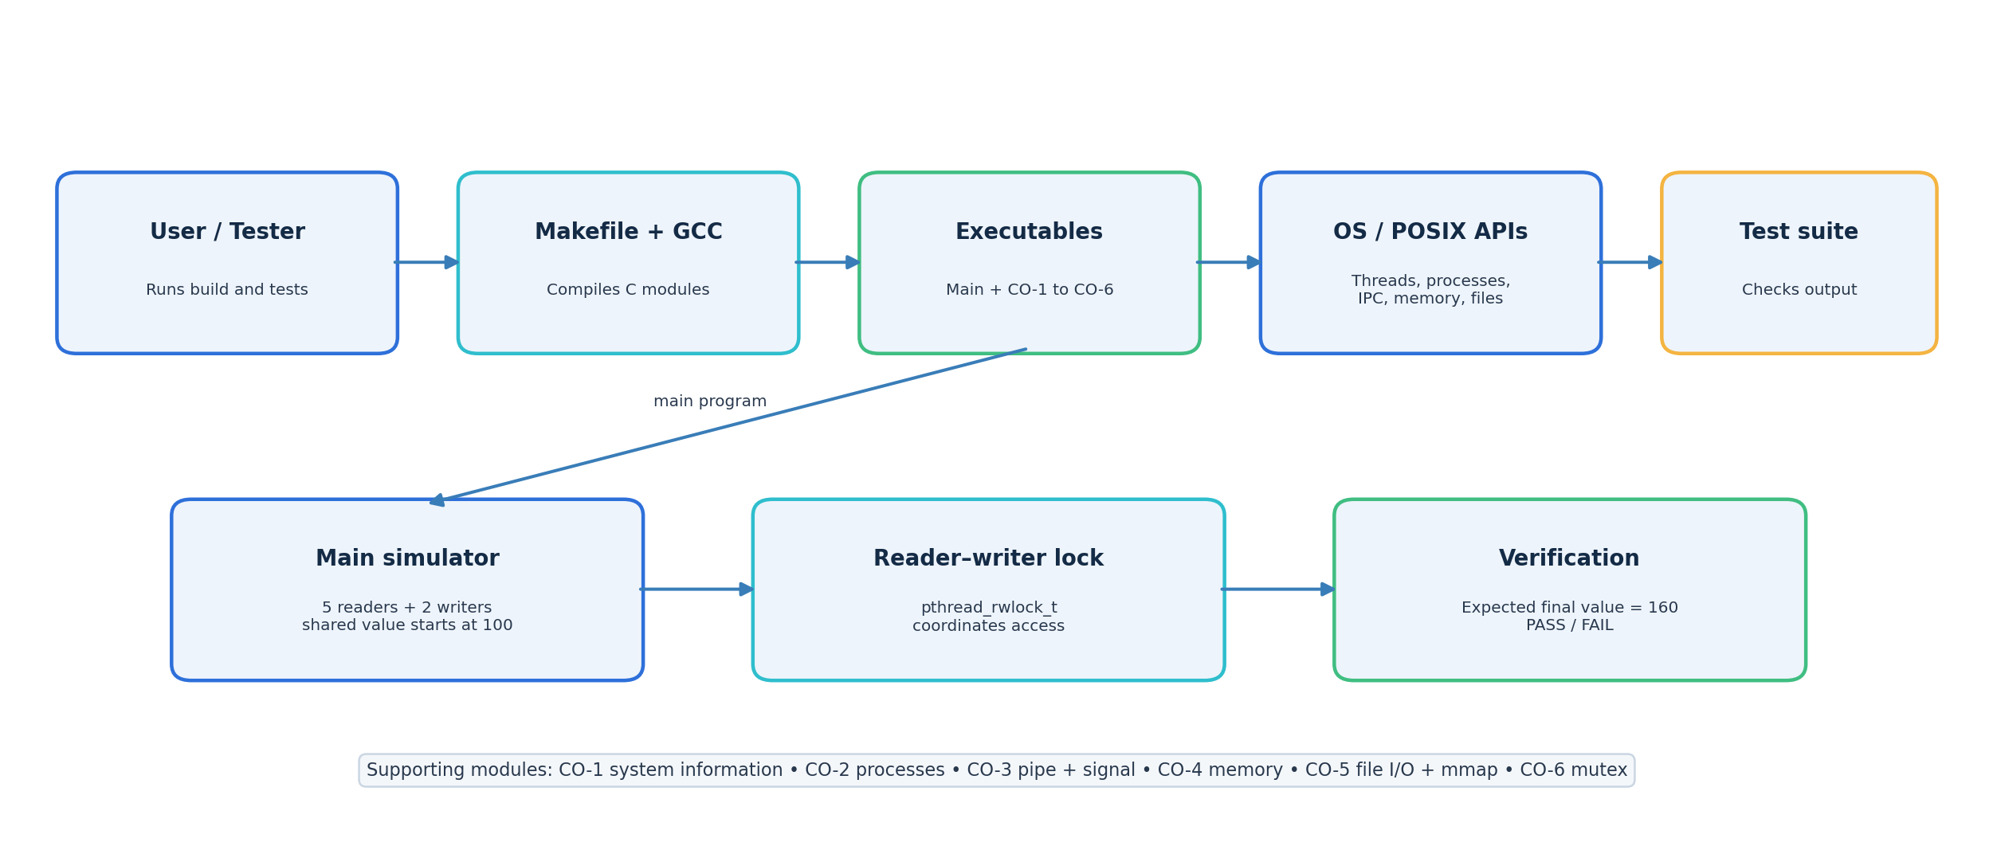
Figure 1. High-level system architecture of Team 23's Readers–Writers simulator.
Layer / Component | Responsibility
User / tester | Runs build and test commands from the terminal.
Makefile and GCC | Compile source files into executable programs.
Main Readers–Writers simulator | Creates reader/writer threads and coordinates access to a shared integer.
Reader–writer lock | Protects shared state according to read/write access rules.
CO-1 to CO-6 modules | Demonstrate system information, processes, IPC, memory, files, and concurrency.
tests/run_tests.sh | Runs seven programs, captures logs, checks expected output, and summarizes results.

6.2 Main simulator data flow
- Initialize the shared database value to 100.
- Initialize the reader–writer lock.
- Create five reader threads and two writer threads.
- Reader threads acquire read access before inspecting the shared value.
- Writer threads acquire exclusive write access before adding 10.
- Each writer performs three increments, giving six increments in total.
- Join all created threads and destroy the lock after successful completion.
- Compare the final value with the expected value 160 and print PASS or FAIL.
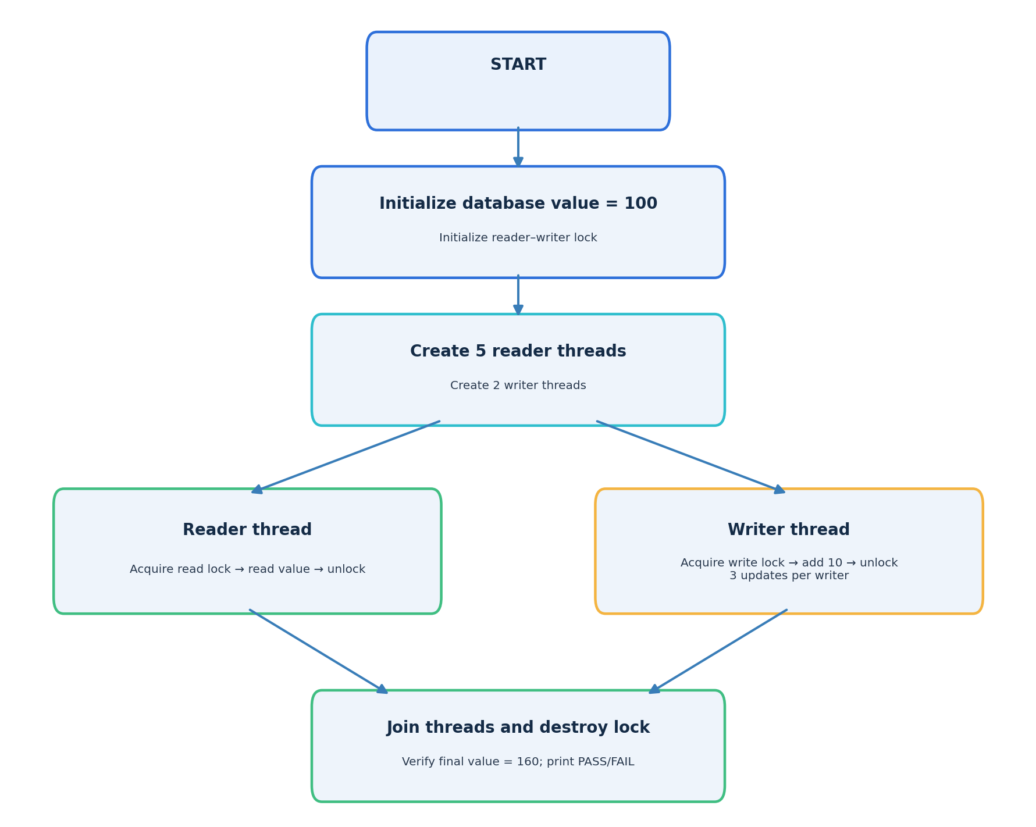
Figure 2. Main Readers–Writers execution flow.

6.3 Expected value calculation
Initial value = 100. Number of writers = 2. Increments per writer = 3. Increment size = 10.
Total increase = 2 × 3 × 10 = 60.
Expected final value = 100 + 60 = 160.

6.4 Concept-module map
Module | Primary concept | Representative mechanisms
CO-1 | OS information / service layer | PID, PPID, UID, Linux kernel and machine information
CO-2 | Process management | fork(), execlp(), waitpid()
CO-3 | IPC | anonymous pipe, SIGUSR1, child/parent coordination
CO-4 | Memory management | dynamic allocation, /proc information, fork() copy-on-write
CO-5 | File operations | open/read/write/lseek/fstat/mmap/munmap/close
CO-6 | Concurrency | threads, shared counter, pthread_mutex_t

7. Project Directory Structure
readers-writers-simulator/
├── src/
│ ├── main.c
│ ├── co1_system_info.c
│ ├── co2_process.c
│ ├── co3_ipc.c
│ ├── co4_memory.c
│ ├── co5_file_io.c
│ └── co6_concurrency.c
├── include/
├── tests/
│ └── run_tests.sh
├── docs/
├── presentation/
├── bin/
├── Makefile
└── README.md
The source directory contains the C programs. The include directory is reserved for shared headers if required. The tests directory contains the automated test runner. The bin directory contains compiled executables. The docs and presentation directories can hold the report, diagrams, and presentation material.

8. Implementation Details

8.1 Main Readers–Writers simulator
The main program is the central project. It creates a shared integer with initial value 100, then launches reader and writer threads. The synchronization primitive is pthread_rwlock_t. Readers use read-lock access while inspecting the value; writers use write-lock access while modifying it. This design reflects the fundamental rule that multiple readers may share access, whereas a writer requires exclusive access.
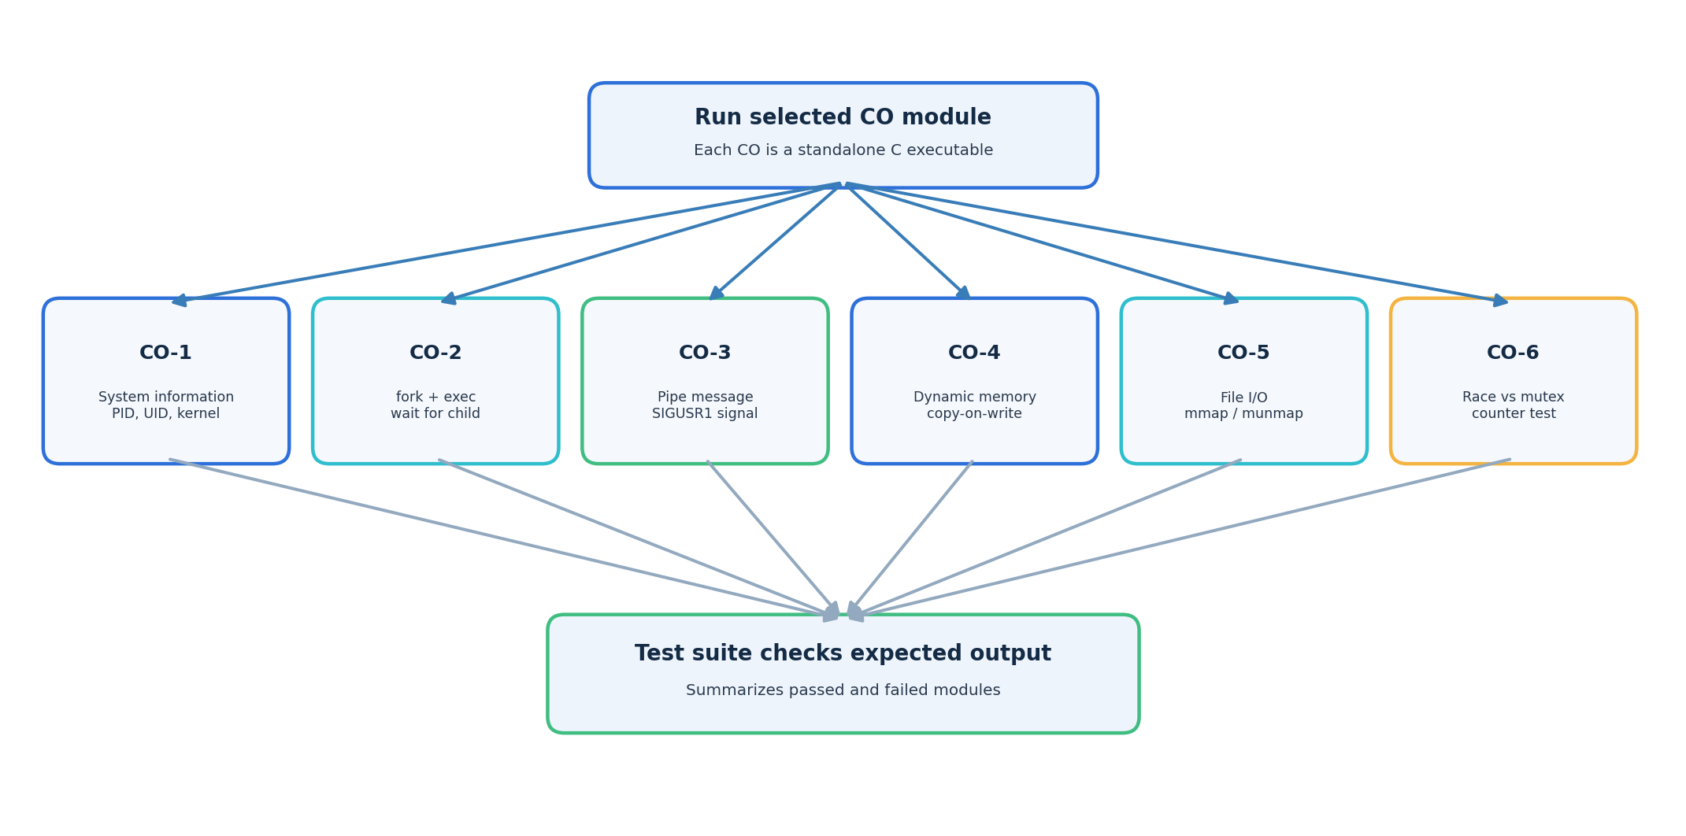
Figure 3. Overview of the six standalone CO demonstration modules.
There are five readers and two writers. Each writer increments the value by 10 on three occasions. Consequently, the final value should be 160 regardless of the order in which writer operations occur, provided each planned write completes successfully and the lock is used correctly.

8.1.1 Important synchronization rules
- Acquire the appropriate lock before touching the shared value.
- Release the lock after the critical section.
- Do not destroy the lock until worker threads have completed.
- Check thread creation and join results so that failures are not silently ignored.
- Verify the final value instead of relying only on visual inspection.

8.2 CO-1: OS as a Service Layer
This module queries and displays operating-system and process information. The reported output includes PID, PPID, UID, operating system, kernel release, machine architecture, and online processor count. It demonstrates that programs can request information from the OS through standard library and Linux-specific interfaces.
Validation checks that the output identifies Linux and includes the kernel release, machine architecture, and online processor information.

8.3 CO-2: Process Management
This module demonstrates parent-child process behavior. The parent records its process ID and calls fork(). The child replaces its program image with the ls command using execlp(), listing the contents of the src directory. The parent waits for the child using waitpid() and reports the child's exit status.
The exec call replaces the child process's program image. Any output buffered by the child but not flushed before execlp() can be lost when the new program image replaces the old one. The current test therefore verifies observable behavior: the parent waits, the directory listing appears, the child exits successfully, and the parent completes.

8.4 CO-3: Inter-Process Communication
This module uses an anonymous pipe to send a message from the parent to the child. The child reads and displays the message. The child then sends SIGUSR1 to the parent as a notification. The program checks the relevant outcomes and reports successful completion.
The demonstration separates two concepts: the pipe transports message bytes, while the signal notifies the parent that an event has occurred. The test checks for the expected message, child completion, and parent receipt of SIGUSR1.

8.5 CO-4: Memory Management and Copy-on-Write
This module allocates memory dynamically, reports memory-related information using Linux's /proc interface, and creates a child process. The child changes the first array value from 10 to 999. The parent subsequently reports that its own value is still 10. This demonstrates the logical separation of process address spaces and copy-on-write behavior after fork(). The program also reports that dynamic memory has been released.

8.6 CO-5: File Operations and Memory Mapping
This module creates a demonstration file named database_record.txt and writes the text 'Readers-Writers Database Simulator'. It demonstrates explicit file access and mapped access. The program uses file operations such as read(), lseek(), and fstat(), maps the file with mmap(), releases the mapping with munmap(), and closes the file descriptor.
The test verifies that the file was created, the output labels for read() and mmap() appear, the expected record text is present, and the file descriptor is closed successfully.

8.7 CO-6: Thread Synchronization and Race Conditions
This module compares two counter experiments. In the first experiment, multiple threads increment a shared counter without a mutex. This is intentionally unsafe: concurrent conflicting access to a non-atomic shared variable is a data race in C and results in undefined behavior. The observed value can vary between runs and must not be relied upon.
In the second experiment, a pthread_mutex_t protects the shared counter. Four threads perform 100,000 increments each, so the expected protected result is 400,000. The module verifies the mutex-protected result and reports that the mutex prevented lost updates.
The demonstration is educational. The unprotected result is not guaranteed to be smaller than 400,000, and a particular observed result does not prove that the unsafe implementation is correct.

8.8 Build and test automation
The Makefile builds the main simulator and the CO executables. The test script executes each program with a timeout, captures standard output and standard error into temporary log files, and checks for expected text. The final report gives passed, failed, total, and overall result counts.
The team's latest test output reported seven passed tests, zero failed tests, and an overall PASS result.

9. Build and Execution Guide

9.1 Open the project directory
cd ~/readers-writers-simulator

9.2 Check required tools
gcc --version
make --version
bash --version
If GCC or make is not installed on Ubuntu, install the build tools with:
sudo apt update
sudo apt install build-essential

9.3 Build all programs
make
The Makefile should compile the main simulator and the CO modules into the bin directory. If the build reports an error, read the first compiler error carefully; later errors can be consequences of the first one.

9.4 Run the main simulator
./bin/readers_writers
Expected key result:
Final value : 160
Verification : PASS
The order of reader and writer messages can vary because threads execute concurrently. The final verified value is the important deterministic result.

9.5 Run individual CO programs
./bin/co1_system_info
./bin/co2_process
./bin/co3_ipc
./bin/co4_memory
./bin/co5_file_io
./bin/co6_concurrency

9.6 Run the complete test suite
make test
The successful run reported:
Passed: 7
Failed: 0
Total : 7
OVERALL RESULT: PASS

9.7 If the test script is not executable
chmod +x tests/run_tests.sh
make test

9.8 If you need a fresh build
make clean
make
make test
Use make clean only if the Makefile defines that target. If it does not, use make and then make test.

10. Testing Strategy and Results

10.1 Testing approach
The project uses output-based integration checks. Each executable is run separately under a timeout. The script captures output to a log file and searches for important expected lines. A module passes when its required checks succeed.
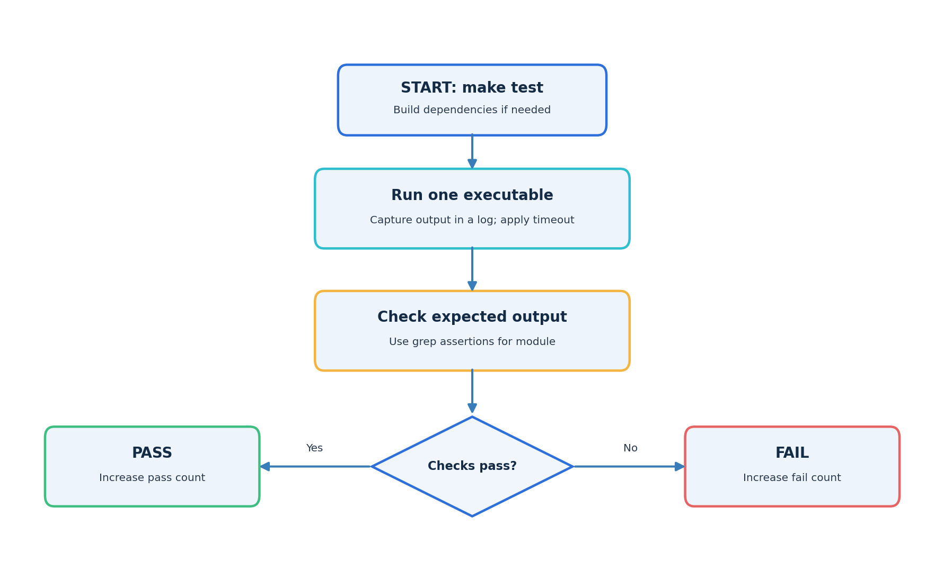
Figure 4. Automated test workflow.

10.2 Test cases
No. | Test case | Main checks | Result
1 | Readers–Writers Synchronization | Final value is 160; verification reports PASS | PASS
2 | System Information and OS Services | Linux, kernel release, architecture, processor count | PASS
3 | Process Management | Parent waits; ls output appears; child status 0; parent completes | PASS
4 | Inter-Process Communication | Pipe message, child completion, SIGUSR1 notification | PASS
5 | Memory Management and Copy-on-Write | Child value 999; parent value 10; memory released | PASS
6 | File Operations and Memory Mapping | File created; read and mmap output; expected content; descriptor closed | PASS
7 | Thread Synchronization and Race Conditions | Data-race demonstration, mutex result 400000, verification PASS | PASS

10.3 Final test summary
Metric | Value
Passed | 7
Failed | 0
Total | 7
Overall result | PASS

10.4 Meaning of the results
The result confirms that all seven checks defined by the current test script passed in the reported run. It is evidence that the expected output was produced for those checks. It does not constitute a formal proof of correctness, exhaustive stress testing, or a guarantee that every possible thread interleaving has been tested.

10.5 Suggested additional tests
- Run the main simulator repeatedly to check that the final value remains 160.
- Run the project under a thread analysis tool, where available, to investigate concurrency issues.
- Test error paths such as allocation failure or process-creation failure where practical.
- Check that temporary files and generated binaries are in expected locations.
- Review test assertions periodically when program output labels change.

11. Output Interpretation

11.1 Main simulator
The reader and writer messages may appear in different orders from run to run. This is normal in concurrent programs. The expected final value is 160 because the writers collectively add 60 to the initial value of 100. A final value of 160 together with Verification: PASS indicates that the main program's final-value check succeeded.

11.2 Process-management module
The ls -l src output comes from the child after execlp() replaces its program image. The parent waiting message and successful exit status show that the parent coordinated with the child instead of immediately exiting.

11.3 Copy-on-write module
The child printing 999 and the parent printing 10 illustrates that modifying the child's copy does not change the parent's logical value.

11.4 File I/O module
The same demonstration record is shown through explicit file reading and memory-mapped access. The module then releases the mapping and closes the descriptor.

11.5 Concurrency module
The unprotected counter may vary. The protected counter should reach 400,000 because the mutex serializes each critical update. The verification result is based on the protected experiment.

12. Security, Reliability and Technical Considerations
- The project should be run as a normal user; administrative privileges are not generally required.
- The CO-6 unprotected data-race experiment is intentionally unsafe and should remain isolated from important application data.
- The file demonstration creates or truncates database_record.txt in its working directory; avoid running it in a directory containing a valuable file with the same name.
- A timeout in the test suite prevents a program that hangs from blocking the entire test run indefinitely.
- Thread and process return values should be checked to detect failures.
- Signal handlers should use only operations appropriate for signal-handler context; keep complex work outside a signal handler.
- Output-based tests are useful but should be supplemented with code review and, when possible, concurrency analysis tools.

13. Limitations
- The database is represented by a single integer, not a persistent database engine.
- The project runs in a terminal and has no graphical interface.
- The test suite checks selected output patterns rather than every internal state or execution path.
- Thread scheduling and message order are nondeterministic, so complete output order can vary.
- The unsynchronized counter example contains a data race and cannot be used to make reliable performance or correctness claims.
- The demonstrations are designed for Linux/POSIX environments and may require changes on non-POSIX operating systems.

14. Future Enhancements
- Allow reader count, writer count, initial value, and increment size to be configured at runtime.
- Add a persistent record store or a small file-backed database abstraction.
- Collect wait times, throughput, and lock-acquisition statistics.
- Add stress tests with varied thread counts and repeated executions.
- Use tools such as ThreadSanitizer where supported to analyze data races.
- Generate machine-readable test reports in addition to terminal output.
- Add a visual timeline showing thread states and lock ownership.
- Add command-line options to run a single CO module or the complete test suite.
- Improve cleanup and error-path testing for resource allocation and system-call failures.

15. Conclusion
The Readers–Writers Concurrent Database Simulator demonstrates an important operating-systems challenge: coordinating concurrent access to shared data. The main program uses a POSIX reader–writer lock to coordinate five readers and two writers. Starting from 100, the writers perform six increments of 10, so the expected final value is 160. The program verifies this result and reports PASS when the expected value is reached.
The supporting CO modules broaden the demonstration to include Linux system information, process creation and execution, pipe-based communication and signal notification, dynamic memory and copy-on-write, file operations and memory mapping, and thread synchronization using a mutex. Together, these modules provide a compact practical tour of OS concepts through C programs and terminal output.
The automated test suite completed with seven passed tests and zero failures. This gives the team repeatable evidence that the expected checks succeeded in the reported run. The project remains an educational simulator, and future improvements can add stronger stress testing, performance measurements, configurable scenarios, and richer reporting.

16. References and Appendix

16.1 Technical references
- Linux manual pages: fork(2), exec(3), waitpid(2), pipe(2), mmap(2), read(2), write(2), lseek(2), fstat(2), close(2), pthread_create(3), pthread_rwlock_init(3), pthread_mutex_lock(3).
- The Linux man-pages project: https://man7.org/linux/man-pages/
- The GNU Make manual: https://www.gnu.org/software/make/manual/
- GCC documentation: https://gcc.gnu.org/onlinedocs/
- POSIX threads and system interfaces documentation for the target Linux environment.

16.2 Useful command summary
Task | Command
Go to project | cd ~/readers-writers-simulator
Build programs | make
Run main simulator | ./bin/readers_writers
Run one CO module | ./bin/co1_system_info (replace with desired executable)
Run full tests | make test

16.3 Project team
Student ID | Name
2520030303 | PODILA BHARGAVA RAMA SASTRY
2520030164 | MARGANI DIJENDRA VENKAT KUMAR
2520030069 | GIRINENI HEMASWI

